**Experiment No. 04**

**Object:** To allow telnet of the Switch to connected End-Devices

**Date:** February 24, 2018

# Configuration Figure:

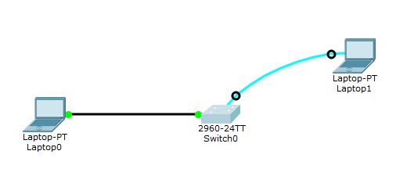

# Coding:

Switch>enable

Switch#configure terminal

Enter configuration commands, one per line. End with CNTL/Z.

Switch(config)#inte

Switch(config)#interface v

Switch(config)#interface vlan 1

Switch(config-if)#ip ad

Switch(config-if)#ip address 192.168.0.10 255.255.255.0

Switch(config-if)#no shut

Switch(config-if)#no shutdown

Switch(config-if)#

%LINK-5-CHANGED: Interface Vlan1, changed state to up

%LINEPROTO-5-UPDOWN: Line protocol on Interface Vlan1, changed state to up

Switch(config-if)#ex

Switch(config)#

Switch(config)#

Switch(config)#line vty 0 4

Switch(config-line)#tran

Switch(config-line)#transport input telnet

Switch(config-line)#login local

Switch(config-line)#username ali secret 1234

Switch(config)#enable sec

Switch(config)#enable secret 1234

Switch(config)#exit

Switch#

%SYS-5-CONFIG_I: Configured from console by console

Switch#exit

Switch con0 is now available

Press RETURN to get started.

Switch>

Switch>exit

Switch con0 is now available

Press RETURN to get started.

Switch>

Switch>

# Command Prompt Result:

